COMPUTER SCIENCE FUNDAMENTALS AND CAREER PATHWAYS

Assignment 1

TOPIC : Real Life Scenario of Canteen Food Ordering System

NAME : Dolare Shruti Manohar

ROLL NO: 2501730066

BTech CSE (AI ML)

SECTION : C

INTRODUCTION

In our college canteen, students often have to stand in long lines just to order food. This takes time and creates rush during lunch hours. A canteen food ordering system makes this process easier and faster.
It allows students to select food items, checks the total amount, and gives a bill instantly. It also helps the canteen staff manage orders properly without confusion.
In this project, we will design a simple computer-based food ordering process using computational thinking.
PROBLEM ANALYSIS

ABSTRACTION:
For our canteen system, we only need:
- Food Menu (Items and Prices)
- Students food choices and quantity
- Bill calculation and payment option

DECOMPOSITON:
- Show food menu with prices
- Take students order and quantity
- Calculate total amount
- Ask for payment method
- Confirm and print amount bill

PATTERN RECOGNITION:
This system is similar to:
- Ordering food on swiggy or zomato
- Buying snacks from a vending machine

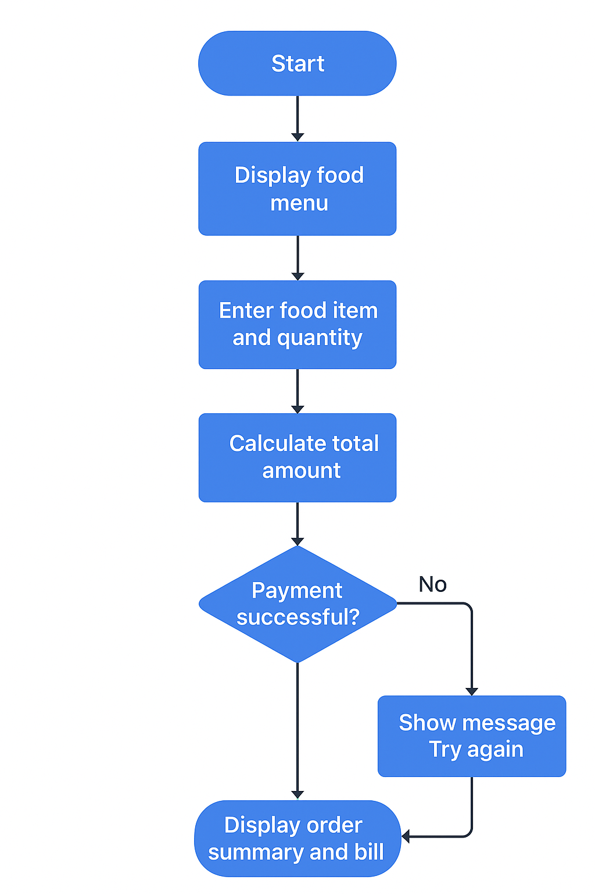

PSEUDO CODE

- Start
- Display food menu
- Select and input required food items and quantity
- Calculate total bill amount
- Input payment method (cash / UPI)
- If payment successful :
- Proceed and confirm the order and
display order summary.
- Else, display “Payment failed, please try again”
- End
REFLECTION

While making this project, I learned how to use step-by-step thinking (computational thinking) in real life.
Breaking the process into small steps helped me write correct logic. I also understood how simple programs can handle daily activities like food orders.
If I improve it later, I’ll add features like multiple items in one order, automatic total calculation for multiple dishes, and order tracking.

CONCLUSION

The canteen food ordering system helps save time and avoids crowding. It makes the work easier for both students and staff.
This simple program shows how computer logic can be used in small real-world problems to make our life simpler and faster.

